Sporty Shoes Project Specification Document

Course : Implement Frameworks the DevOps way

Programmer Details: Diksha Pratap Kadam

Git Hub Link: <https://github.com/RemyaPillai99/HappyHeelsWebsite>

**Project Details:**

Sporty Shoes is an E-Commerce application that lets people buy sports shoes on their website.

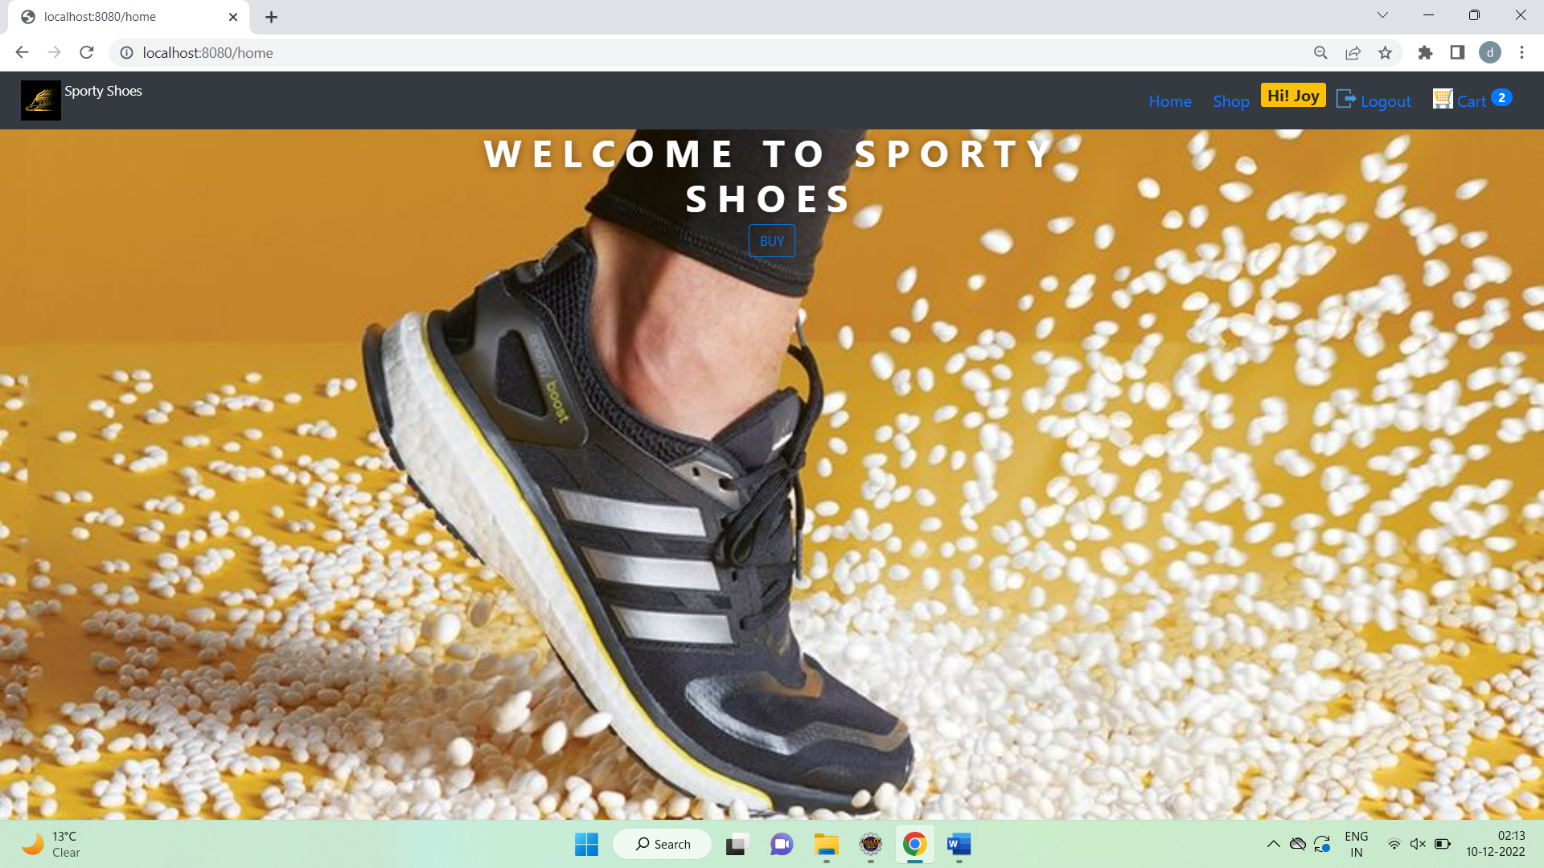

## Website Flow

**Home page**

* Home page displays options to Shop for Shoes, Login and Cart.
* Customer can login with existing credentials or sign up if desired

**Shop Page Customer Flow** –

* In Shop page Customer is able see the all products list and view the selected product detail
* Customer has option to View All Products or Select products from specific categories from the side nav bar
* Customer can add product to Cart
* Cart icon on the nav bar also shows the total cart item count.
* The selected products are added in the cart, user can remove products from cart or add multiple products in the cart
* Customer should be logged in to be able to check out cart.
* On checkout the customer is redirected to checkout page where they will enter billing details and pay the cart amount
* After the cart amount is paid customer is redirected to Confirmation page which shows the Order Number.
* The order details are persisted in the database

**Admin Login** -

* Admin can login into website with their credentials
* If the details provided are correct admin is sent to Admin Management Page
* In Admin Dashboard page admin can see all management options
* Admin can manage Categories (Perform All CRUD Operations)
* Admin can manage Products (Perform All CRUD Operations)
* Admin can view all registered Customers and search by any criteria field
* Admin can see purchase report of all the purchases done in the system, can also filter the results by Category and order date.

## Technologies Used

**Frontend** - JSP, HTML, CSS, Bootstrap4, jQuery  
**Backend** - JAVA, Spring boot, JPA , Maven   
**Database** - MySQL  
**Application Server** - Tomcat v9.0

## Project Structure

## 

## 

## 

## 